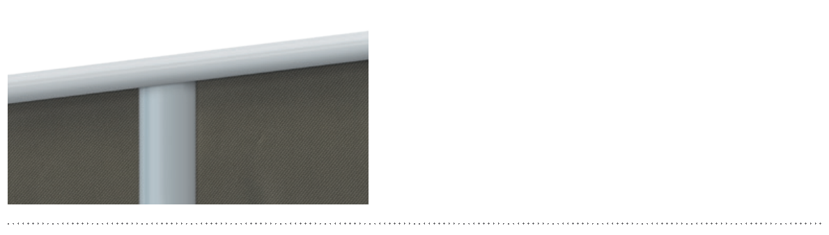
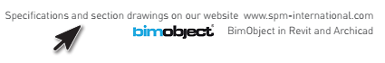

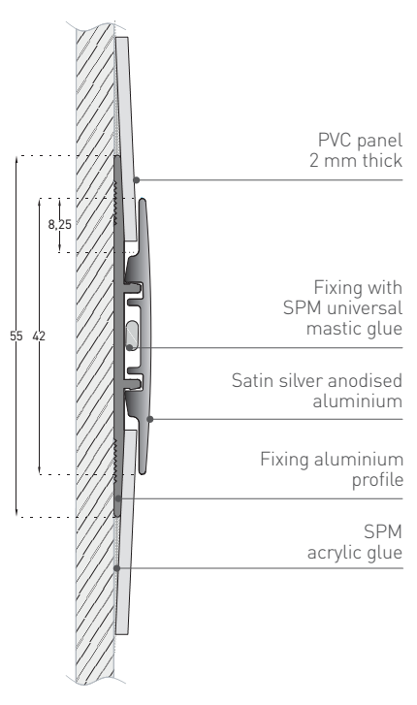
SPECIFICATION

FIN’ALU – JOINTING PROFILE H SHAPE
JOINTING PROFILE FOR 2 MM PANELS
DECOCHOC, DECOSMIC, DECOWOOD ET DECOTREND PANELS

- Description: jointing profile (H shape) in satin silver anodised aluminium (Fin’Alu jointing profile in H shape as manufactured by SPM) designed for vertical or horizontal jointing between 2 mm thick protection panels (Decochoc, Decosmic, Decowood or Decotrend as manufactured by SPM). Smooth surface. The profile, 3 m long and 42 mm wide (visible part), glues onto the continuous aluminium rail, 55 mm wide (hidden part), fixed to the wall by gluing or screwing.
- Colour: selected by architects from manufacturer’s standard range.
- Installation method: gluing onto aluminium rail to glue or screw to wall as per manufacturer’s instructions.

SPECIFICATION

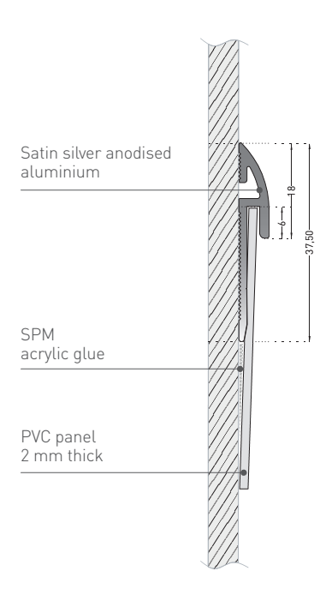
FIN’ALU – FINISHING PROFILE J SHAPE
FINISHING PROFILE FOR 2 MM PANELS
DECOCHOC, DECOSMIC, DECOWOOD ET DECOTREND PANELS

- Description: finishing profile (J shape) in satin silver anodized aluminium (Fin’Alu finishing profile in J shape as manufactured by SPM) designed for vertical or horizontal finishing for 2 mm thick protection panels (Decochoc, Decosmic, Decowood or Decotrend as manufactured by SPM). Smooth surface, 3 m long, 18 mm wide for the visible part and 37.5 mm for the hidden part fixed to the wall.
- Colour: selected by architects from manufacturer’s standard range.
- Installation method: glue as per manufacturer’s instructions or screwing to wall.


